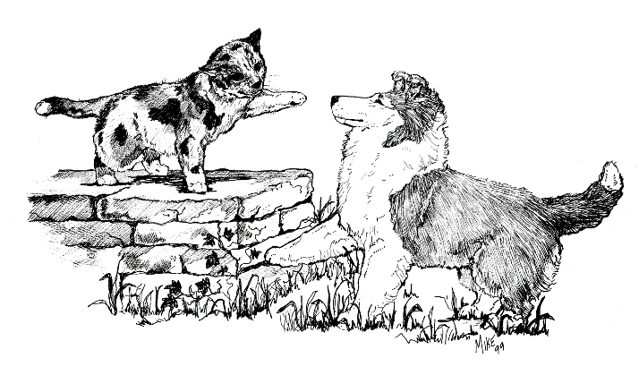
Animal Dental Center of WNY
3000 Genesee Street
Cheektowaga, NY 14225
(716) 896-2424
David E. Hansen, DVM, FAVD, Dip. AVDC

Dental Referral Policy & Agreement

Owner: ______________________________________________________________________________
Address: _____________________________________________________________________________
City:_______________________________ State: ____________ Zip Code:________________________
Home #: _______________________ Cell:__________________ Work:__________________________
Email Address:________________________________________________________________________
It is our policy to present you with a written estimate of our fees at the time of admission. This will include all expected services, examinations, tests, surgery & medications. Emergency services (if necessary) will carry additional charges. If additional services are necessary, we will call you for verbal consent. Please be sure that we have an adequate telephone number where you can be reached if needed.
Payment is expected in full at the time of your pets discharge. We accept cash, Visa, MasterCard, Discover, American Express & Care Credit. Checks will only be accepted with proper photo ID.
We may require a deposit in advance.

Because your pet has been referred to us for a dental procedure, upon completion of this procedure we will forward all the pertinent information to your regular veterinarian. We will only treat the original problem for which your veterinarian has referred you. In the event that your pet requires medical help in the future, which is not specifically related to this procedure, we recommend that you call your regular veterinarian. His/her skill and familiarity with your pet makes your veterinarian the best-qualified professional to manage additional problems.

I have read and understand this policy. I further agree to abide with its provisions.

Signature: ____________________________________________________ Date: ___________________

Patient Information

Pet Name: ______________________________________ Circle one
Breed: _________________________________________ Dog or Cat
DOB/Age: ______________________________________ Male or Female
Color: _________________________________________ Spayed or Neutered

Referring Hospital: _____________________________ Doctor: ________________________________

Does your pet have a history of:
- Allergies (if so what kind): _________________________________________________________
Have they been treated? __________________________________________________________
Are they under control? __________________________________________________________
Have medication been tried (if so what kind)? _________________________________________
- Recent surgeries or anesthetized procedures (please include dates): ____________________________________________________________________________________________________________________________________________________________
Were there any problems or complications with anesthesia (slow recovery, prolonged lethargy, etc)? __________________________________________________________________________
- Illnesses or conditions (treated by your veterinarian other than what you are here for today) ____________________________________________________________________________________________________________________________________________________________
Is your pet currently on any medications (this includes flea/tick/heartworm preventives, dewormers, vitamins, over the counter medications, or any medication your veterinarian has prescribed)? _______________________________________________________________________________________________________________________________________________________________________________________________________________________________________________________________

Are there any new or different symptoms that your pet has shown pertaining to the reason why you are here today, over the past 3 months? __________________________________________________________________________________________________________________________________________________________________________

Is there any other information about your pet that you feel is important for us to know? _____________________________________________________________________________________

